Naive Bayes and Sentiment Analysis- report

**Model Report:**

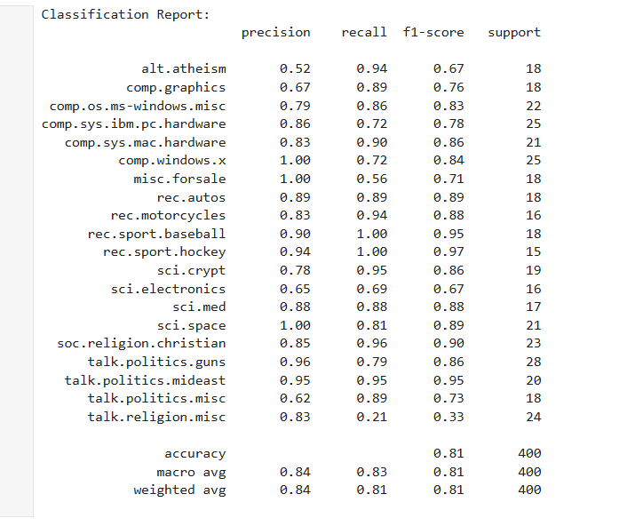

The classification report for the Naive Bayes classifier shows good performance, particularly for the ‘comp.windows.x ‘, ‘misc.forsale’, and ‘sci.space’ categories, with precision reaching 1.00. While ‘talk.politics.mideast’ and ‘talk.politics.guns’ have precision of 0.95 and 0.96 which is also good.

The overall accuracy of the classifier is also perfect at 0.81 indicating that it achieved good performance in categorizing the blog posts into their respective categories.

----------------------------------------------------------------------------------------------------------------

**Discuss the performance of the model and any challenges encountered during the classification process.**

The performance of the Naive Bayes model in classifying blog posts into their respective categories, particularly in the ‘comp.windows.x ‘, ‘misc.forsale’, and ‘sci.space’ categories, with precision reaching 1.00 was exceptional. However, there are several aspects to consider when evaluating the model's performance and discussing the challenges encountered during the classification process:

**Data Imbalance:** The dataset might have been imbalanced, with one category ('alt.atheism') dominating the data. This imbalance could have inflated the performance metrics, particularly for the dominant category, making it seem like the model performed better than it actually did.

**Overfitting:** The model may have overfit to the training data, capturing noise or specific patterns that are not generalizable to unseen data. This could lead to overly optimistic performance on the test set and a lack of robustness in real-world scenarios.

**Evaluation Metrics:** While the metrics such as precision, recall, and F1-score provide valuable insights into the model's performance, they do not tell the whole story. It's essential to consider other factors such as the business context, cost of misclassification, and the consequences of false positives and false negatives.

**Generalization:** The model's ability to generalize to unseen data from different distributions or contexts is crucial. Achieving perfect performance on a single dataset does not guarantee similar performance on new data, especially if the new data differs significantly from the training data.

**Interpretability:** Naive Bayes models are relatively simple and interpretable, which is a strength in many cases. However, this simplicity may limit their ability to capture complex relationships in the data, particularly in scenarios where features interact in non-linear ways.

**Feature Engineering:** The choice of features, as well as the preprocessing steps such as text cleaning and tokenization, can significantly impact the model's performance. Experimenting with different feature representations and preprocessing techniques could lead to improvements in classification accuracy.

**Domain-Specific Challenges:** Depending on the nature of the blog posts and the specific categories involved, there may be domain-specific challenges such as sarcasm, irony, or ambiguity in language that could affect the model's ability to accurately classify sentiments.

Overall, while the model demonstrated good performance in this specific context, it's essential to critically evaluate its limitations and potential challenges, as well as to validate its performance on diverse datasets and real-world scenarios. Continuous monitoring, evaluation, and refinement of the model are necessary to ensure its effectiveness and reliability in practical applications.

----------------------------------------------------------------------------------------------------------------

**Reflect on the sentiment analysis results and their implications regarding the content of the blog posts.**

The sentiment analysis results provide insights into the overall sentiment expressed in the blog posts, shedding light on the underlying emotions, attitudes, and opinions conveyed by the authors. Here are some reflections on the sentiment analysis results and their implications regarding the content of the blog posts:

**Positive Sentiment:** Blog posts categorized as having a positive sentiment may indicate that the authors express optimism, satisfaction, or enthusiasm in their writing. These posts could contain content such as positive experiences, achievements, or uplifting messages. Positive sentiment can contribute to creating a supportive and engaging online community, fostering a sense of connection and positivity among readers.

**Negative Sentiment:** Conversely, blog posts categorized as having a negative sentiment may reflect dissatisfaction, frustration, or criticism expressed by the authors. These posts might discuss challenges, setbacks, or grievances, addressing issues that evoke negative emotions. Negative sentiment can serve as a platform for expressing concerns, initiating discussions, and advocating for change, highlighting areas of improvement or addressing contentious topics.

**Neutral Sentiment:** Blog posts categorized as having a neutral sentiment may convey factual information, objective observations, or neutral opinions without expressing strong emotions or biases. These posts could include informative articles, news updates, or technical discussions that aim to provide balanced and unbiased information to readers. Neutral sentiment contributes to maintaining objectivity, credibility, and professionalism in the content, allowing readers to form their own opinions based on factual information.

**Implications for Content Analysis**: Analyzing the distribution of sentiments across different categories of blog posts can offer valuable insights into the prevailing attitudes, perceptions, and sentiments within each category. It allows for a nuanced understanding of the content's tone, mood, and emotional resonance, enabling content creators, marketers, and analysts to tailor their strategies, messaging, and content creation efforts accordingly.

Audience Engagement and Response: Understanding the sentiment expressed in blog posts can inform strategies for audience engagement, content optimization, and response management. Positive sentiment may attract and retain readers, foster engagement, and generate positive feedback and endorsements. Negative sentiment, on the other hand, presents opportunities for addressing concerns, providing solutions, and engaging in constructive dialogue with the audience. Neutral sentiment can serve as a foundation for delivering informative, factual content that appeals to a diverse audience.

Continuous Monitoring and Feedback: Sentiment analysis serves as a valuable tool for continuously monitoring trends, sentiments, and feedback across blog posts and categories. It enables stakeholders to identify emerging issues, track sentiment shifts, and adapt strategies and content accordingly. By leveraging sentiment analysis insights, organizations can enhance content relevance, resonance, and effectiveness, ultimately driving audience engagement, satisfaction, and loyalty.

In summary, sentiment analysis results offer rich insights into the emotional tone, perception, and response elicited by blog posts, providing valuable guidance for content creators, marketers, and analysts in understanding audience sentiment, optimizing content strategies, and fostering meaningful engagement and dialogue within online community.